TECHNICAL PROJECT REPORT

# **Bluetooth-Controlled Car**

# Team Members / Inventors:

|  |  |  |  |  |  |
| --- | --- | --- | --- | --- | --- |
| **S.No.** | **Name** | **Department** | **Designation** | **Mobile** | **E-Mail** |
| 1. | RAHUL KUMAR | ECE | Student | 9610375459 | kumarrahulverma1000@gmail.com |
| 2. | VINAYAK SHARMA | ECE | Student | 9882802083 | [v.707s.harma@gmail.com](mailto:v.707s.harma@gmail.com) |
| 3. | Khushal Thakur | ECE | Mentor | 9646030764 | [khushal.thakur@cumail.in](mailto:khushal.thakur@cumail.in) |
| 4. | Anshul Sharma | ECE | Mentor | 9478697475 | anshulsharma.ece@cumail.in |
| 5. | Kiran Jot Singh | ECE | Mentor | 9463909689 | kiranjotsingh.ece@cumal.in |
| 6. | Divneet Singh Kapoor | ECE | Mentor | 9878422653 | [divneet.ece@cumail.in](mailto:divneet.ece@cumail.in) |

Section – 1 (IPR Related)

# Brief Abstract (500 words):

* Problem my project is solving.
* It is mainly solving two problems first is for carreing thing and the second one is for children as a toy which is controlled with Mobile.
* In brief it can reduce the work of which work in office like in IT sector as it can carry light object or documents from one work place to other.
* However this Bluetooth car can further be modified like a gps, compass can be added so that it can follow the person or reach its specified location.
* It also act as an entertainment for the children as it is more durable and thus lasts long. More over a video camera can be added for security purpose.

# Existing state-of-the-art and Drawbacks in existing state-of-the-art

|  |  |  |
| --- | --- | --- |
| **S. No.** | **Existing state of art** | **Drawbacks in existing state of art** |
| 1 | Arduino development board integrated with Bluetooth and motor driving | https://patents.google.com/patent/CN204045060U/en?q=arduino&q=bluetooth&q=car&oq=arduino+bluetooth+car |
| 2 | intelligent vehicle monitoring and control device based on the Arduino  Abstract | <https://patents.google.com/patent/CN207607376U/en?q=arduino&q=bluetooth&q=car&oq=arduino+bluetooth+car> |

# Novel/Additional modifications that you can propose to improve upon drawbacks

* We can connect this model to GPS,Server and compass to follow the users mobile so that it can use be used to carry luggage.
* We can use an fingerprint lock in it so that it can be secure from robbery and with the help GPS we find our device.
* Improvement can be done in motors and its capacity so that it store more thing and mainly in battery so it can able to move motor and weigh of the luggage.

# Advantages

* Compact.
* Easy to operate and use.
* Doesn’t take much battery.

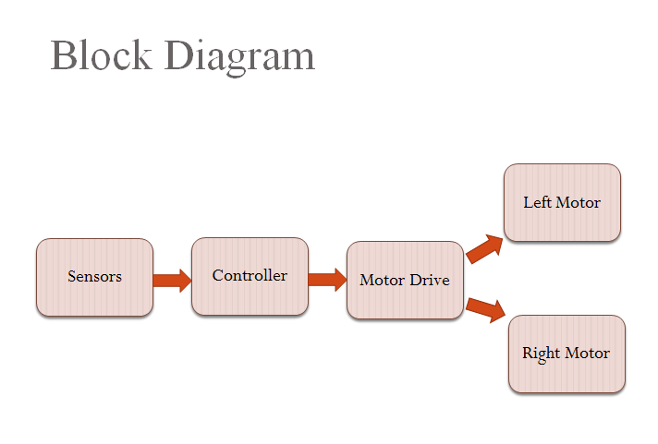

Section – 2 (Real Project)

# Materials

Hello! In this project I will show you how to make a Bluetooth-controlled car which can be controlled through your Android smartphone!

Before starting, make sure that you have:

* Arduino Uno board (Rs. 450)x1
* L298N motor driver (Rs. 170)x1
* HC-05 Bluetooth module (Rs. 299)x1
* An RC car that can fit all the above! (Rs. 350)x1
* Motor controlled wheels(200)x2

Optionally, you will need:

* 1M & 100K resistor for battery level (optional) (Rs. 2)
* Jumper wires (Rs. 20 for 10 pieces)

For power, you can use the existing batteries (4x 1.5V AA), or replace them with a LiOn rechargeable battery pack.

At the time I build mine I use 4 rechargeble battery. If you are using havey power motors for extera load then you can use other battery. So best of luck for the project.

# Circuit Diagram

*Fully functional circuit diagram with exact connections.*

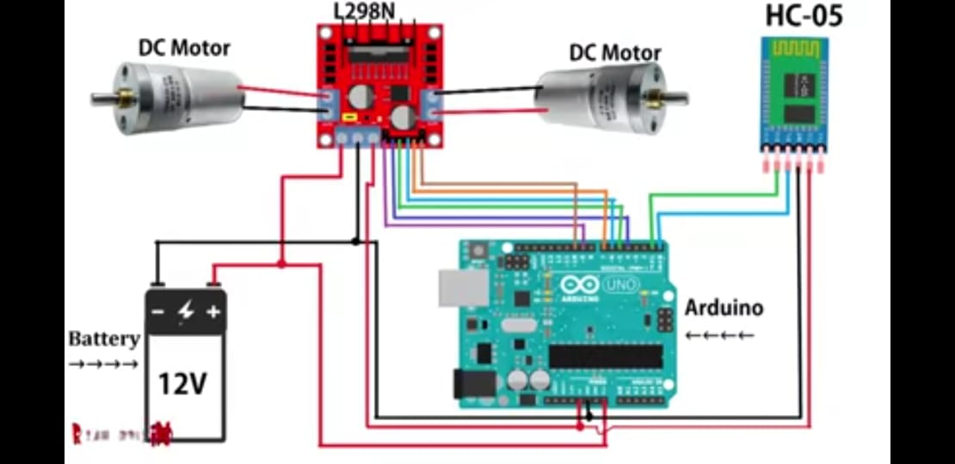

# Steps of Circuit Completion

## STEP 1 CONNECT BLUETOOTH MODULE HC-05 TO ARDUINO ​

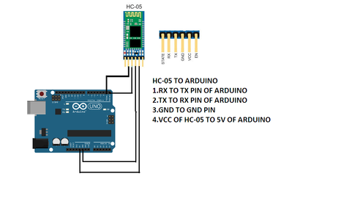

**CONNECTION OF HC-05 TO ARDUINO**1. CONNECT RX PIN OF HC-05 TO TX PIN OF ARDUINO  
2.CONNECT TX PIN OF HC-05 TO RX PIN OF ARDUINO  
3.CONNECT GND PIN OF HC-05 TO GND PIN OF ARDUINO  
4.CONNECT VCC PIN OF HC-05 TO 5V PIN OF ARDUINO  
  
STEP 2 CONNECTION OF MOTOR DRIVER L298N TO ARDUINO  
​

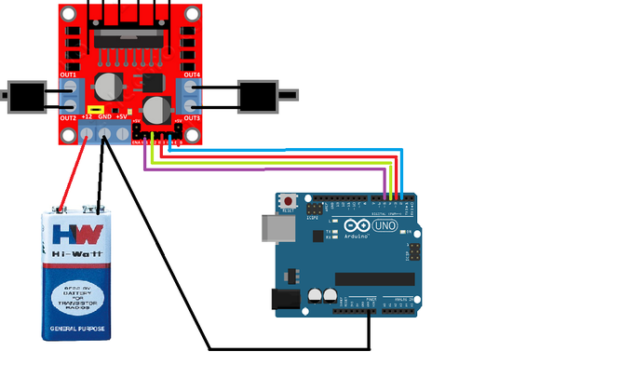

**connection of l298n motor driver to arduino  
1.connect n1 pin of motor to arduino 4 pin  
2.connect n2 pin of motor to arduino 5 pin  
3.connect n3 pin of motor to arduino 6 pin  
4 connect n4 pin of motor to arduino 7 pin  
5.connect en1 pin 0f motor to arduino 9 pin  
6.connect en2 pin 0f motor to arduino 10 pin**

**positive terminal of battery connect to motor as well as negative terminal of battery AND CONNECT TO MOTOR**

**THATS ALL YOU HAVE TO DO**

MAKE SURE ALL THE THE CONNECTIONS ARE TIGHT.

### Tips

* First enable Bluetooth and establish connection with BT module (ex. HC-05, password 1234). If you are unable to upload your program.
* Accelerometer function is under development, use with caution!

Please share your innovative ideas.

"Learning and innovation go hand in hand. The arrogance of success is to think that what you did yesterday will be sufficient for tomorrow."

# Programme Code

AFTER THE COMPLETION OF THE PROJECT

